

Travlr Vacation Website

CS 465 Project Software Design Document
Version 3.0

Table of Contents

CS 465 Project Software Design Document 1
Table of Contents 2
Document Revision History 2
Executive Summary 3
Design Constraints 3
System Architecture View 3
Component Diagram 3
Sequence Diagram 5
Class Diagram 6
API Endpoints 7
The User Interface 7

Document Revision History

Version | Date | Author | Comments
1.0 | <07/15/23> | Tyler Pruitt | Initial Creation of the Software Design Document
2.0 | <07/25/23> | Tyler Pruitt | Addition of Sequence Diagram, Class Diagram, and API Endpoints
3.0 | <08/12/23> | Tyler Pruitt | Addition of Edit and Add trip function, SPA support and Security

Executive Summary

Using MEAN stack for development, the Travlr Vacation website will be created as a web application. The web application will have two parts, a front-end, and a back end. On the front end the interface will be capable of handling the user’s navigation, relaying the appropriate information within each tab. The application will also be able to collect login identification. On the server side there will be a database and a schema for user data files and storage such as the storage of travel booking trips. There will also be an administrator single-page application (SPA). This SPA will be host to several components and services for facilitating the build using the Angular Command Line Interface (CLI).

Design Constraints

Design is limited first to the user’s device. Too complex and the application may run slow or crash on weaker devices. To combat this the application must be as simplistic as possible while fulfilling all the requests. Next is the client-server design. Since the web application is client-server, the design must facilitate consistent transfer of data between these two devices quicky and accurately. Not accounting for this in the design could lead to a slow or non-functioning web application. Finally, the UI should be addressed. The UI must be neat and readable, presenting information in a legible way quickly for the user’s consumption. Cluttered or inappropriate design will turn users away from the web application.

System Architecture View

Component Diagram

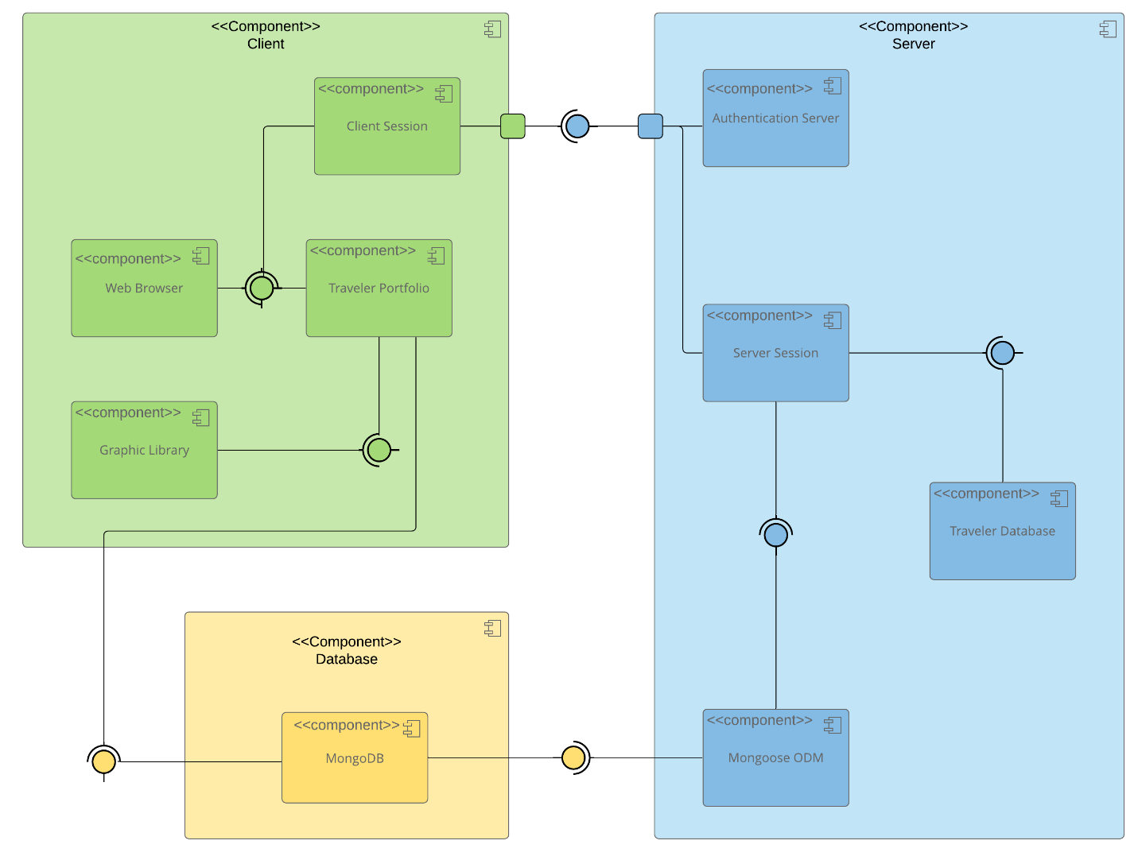
The system’s architecture is split up into 3 components, the client, the server, and the database. The client side is comprised of the client session, which communicates with the server on behalf of the client application. Next is the web browser, which allows for navigation between the tabs and provides the user with the requested views. Then, the traveler portfolio displays the user’s currently downloaded version of the web application. Lastly for the client side, there is the graphic library, which contains the pictures and display information that the web browser displays. The traveler portfolio must contact the database component to receive and the booking information it must display. MongoDB is used as the database in which the traveler portfolio references. When the client session communicates with the server, it is making requests through the authentication server. The authentication server is the first part of the server component which uses the user’s login information to determine what information they can access. If given access, the authentication server allows for communication to the server session. The server session responds to requests and provides the appropriate information. This information is received from two places, the traveler database, which stores the current version of the Travlr web application, and Mongoose ODM, which communicates with MongoDB for the rest of the stored database information such as booking information and history.

Sequence Diagram

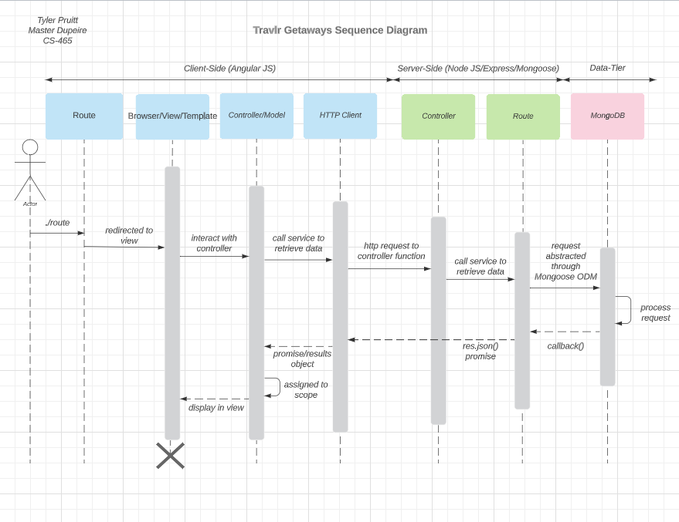

First, the actor navigates to the website. A route then handles the request and sends them to the view. Next, the actor interacts with a controller by, for example, signing in, or clicking an image. This generates a request that the controller passes onto the HTTP client. The HTTP client sends a request to a server-side controller in search of the trips data. Server-side is primarily where admin interactions can take place. A controller takes and processes that request, requesting the route deliver the requested data which the route acquires from the third-party, MongoDB. This is when the callback() begins. The route sends the acquired data back to the client-side HTTP client, where the promise/results object is passed back to the controller. Finally, the results are passed to the view, showing the user what they requested and competing the request.

Class Diagram

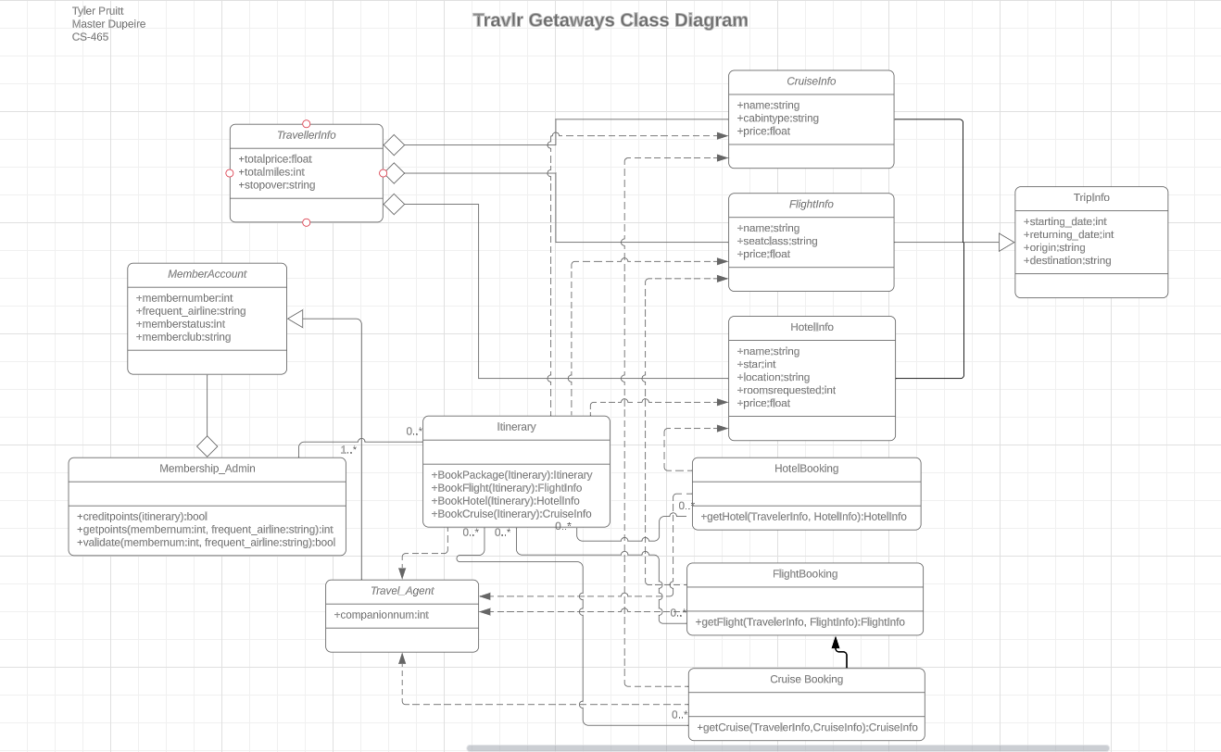
To begin with, the member account class will have four properties: A member number, a frequent airline, a MemberStatus, and a MemberClub. These are the for differentiating the varying customers of Travlr Getaways. Capable of managing these accounts, a Membership_Admin is a special MemberAccount with access to creditpoints, getpoints, and validation. A Membership_Admin may be attributed to 0 or more Itineraries. These Itineraries are BookPackage, BookFlight, BookHotel, BookCruise. The same can be said for HotelBooking, FlightBooking, and CruiseBooking, 0 or more can be attributed to an Itinerary. Each have access to getting HotelInfo, FlightInfo, and CruiseInfo respectively. These info classes each have their own properties. CruiseInfo has a name, a cabintype, and a price. Similarly, FlightInfo has a name, a seatclass, and a price. HotelInfo has a name, star rating, location, rooms requested, and a price value. All of these infos are part of the TripInfo Class, which additionally includes a start date, returning date, origin, and destination value. The infos are also a part of TravellerInfo, which is responsible for a total price, total miles, and stopover values. Last but not least, the Travel_Agent class is necessary as it uses HotelBooking, FlightBooking, CruiseBooking and the Itinerary in varying ways for the MemberAccount.

API Endpoints

Method | Purpose | URL | Notes
GET | <Retrieve Travel List> | </api/trips> | <Returns all active trips>
GET | <Retrieve single thing> | </api/trips/code > | <Returns single trip instance, identified by the reip code passed on the request URL>

The User Interface

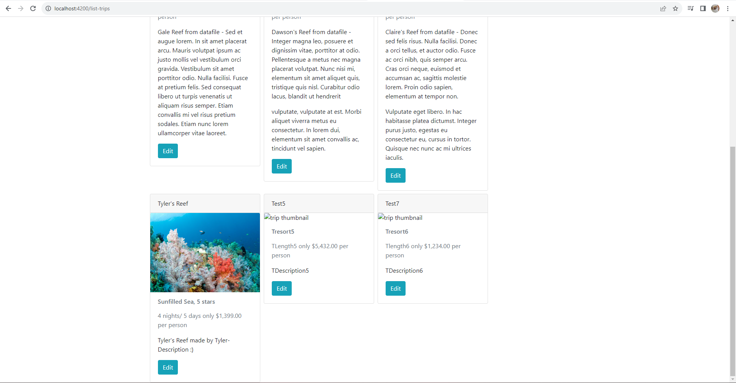
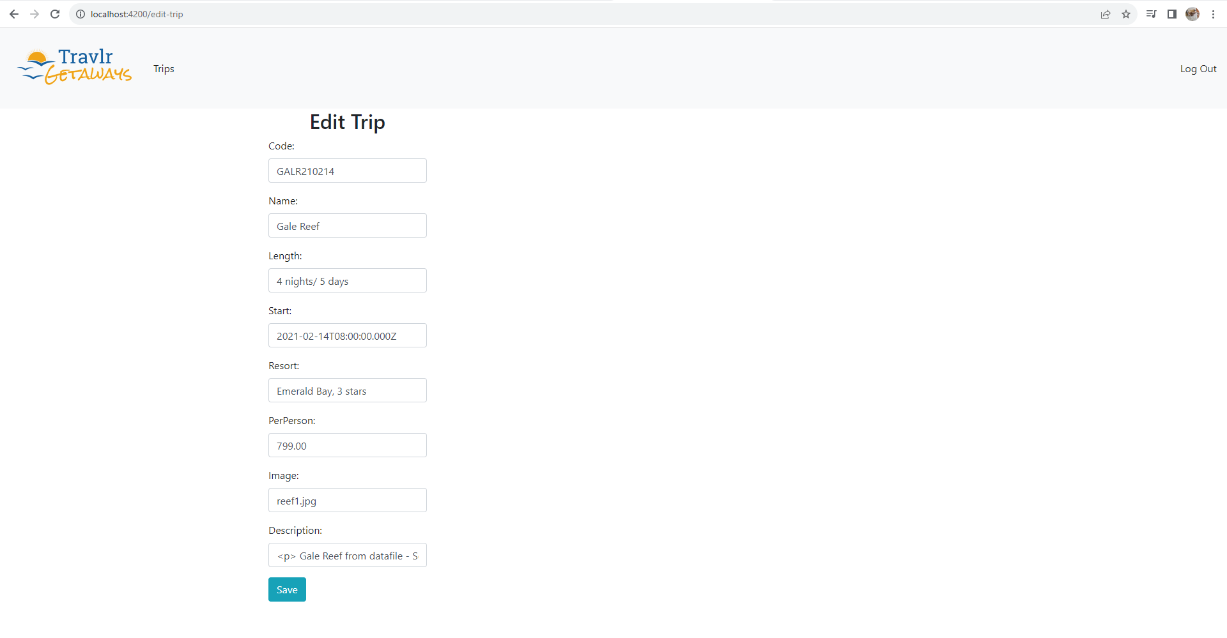
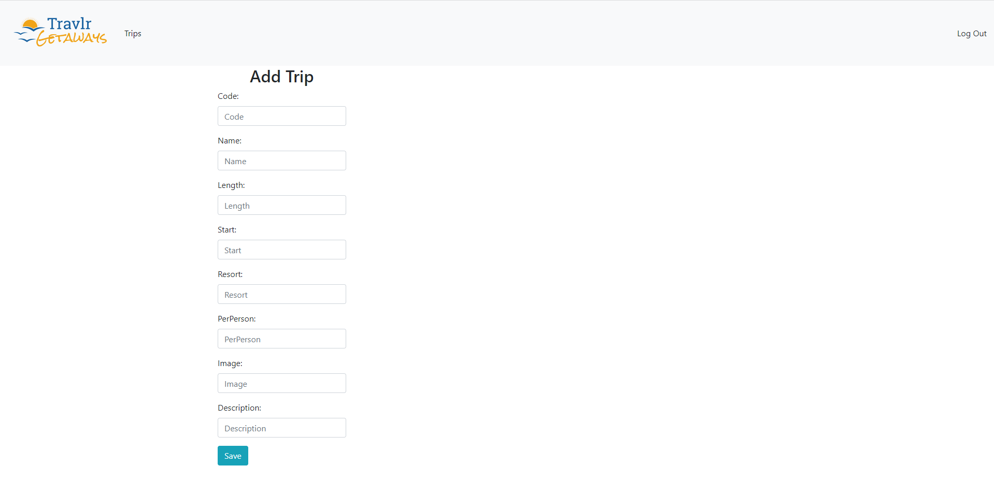

<Summarize the Angular project structure and how it compares to the Express project structure. Be sure to describe the rich functionality provided by the SPA compared to a simple web application interaction. Describe the process of testing to make sure the SPA is working with the API to GET and PUT data in the database.>

The Angular project structure is different because instead of having the whole web page loaded once the user navigates to it, we instead load one page and load more information on request. That means pressing buttons loads the requested data and the view is modified at that point.
The advantage of SPA is that there is less loading time navigating to the website originally. The current site is not large enough now, but a large website could require several minutes or more to open if set up in the same way as the Express HTML customer-facing page. The disadvantages are that there is more frequent loading, since each request needs to process and modify the view. In addition, the view wont change unless a request is made, so the user needs to refresh or press a button to see something new should the SPA change. The additional functionality provided is mostly experience based.
While testing, I used Postman to send Post and Get requests and used the console output as well as the output Postman received to react to errors and issues. Postman is a good representation of both inputs and outputs which made the testing process easier once I knew how to use it properly. It also allows me to test my SPA without having the HTML set up for it.

